Software Requirements Specification (SRS) and Functional Requirements Specification (FRS)

Maturity Benefit Claim Module for IMS 2.0

Table of Contents
1. Introduction 3
1.1 Purpose 3
1.2 Scope 3
1.3 Current Maturity Claim Workflow (McCamish) 3
Step-by-Step Process 3
1. Pending Maturity Report Generation 3
2. Intimation Letter Dispatch 3
3. Claim Submission 3
4. Initial Scrutiny 3
5. Indexing in McCamish 4
6. Document Scanning 4
7. Data Entry 4
8. Claim Handler Verification 4
9. Approval Workflow 4
10. Sanction/Rejection Letter 4
11. Bank Verification 4
12. Disbursement 4
13. Voucher Submission 4
14. Claim Closure 5
15. Customer Communication 5
16. Customer Tracking 5
17. Monitoring & Escalation 5
18. Feedback Collection 5
Detailed Gap Analysis – Maturity Claim Workflow 6
Rejection Reasons Master for Maturity Claim 13
Workflow for the Maturity Process: 14
Screen Samples for the Process: 14
Test Cases: 18

1. Introduction

1.1 Purpose
The purpose of this document is to define the detailed Software Requirements Specification (SRS) and Functional Requirements Specification (FRS) for the Maturity claim module in the upcoming IMS 2.0 insurance management system.

1.2 Scope
The Maturity Benefit module in IMS 2.0 will provide digitalized, automated, and integrated handling of all end-to-end survival benefit (SB) processes, including report generation, multi-channel communication, online claim submission, KYC integration, approval workflows, audit controls, sanction/disbursement, statutory compliance, and real-time analytics.

1.3 Current Maturity Claim Workflow (McCamish)

Step-by-Step Process

Pending Maturity Report Generation
  - On the first working day of each month, CPC manually generates a report listing policies due for maturity in the next two months.

Intimation Letter Dispatch
  - System generates a prefilled intimation letter.
  - Sent via registered post with a blank Maturity Claim Form.
  - SMS/email sent only if available.

Claim Submission
  - Insurant submits the filled claim form and original documents physically at BO/SO/CPC.

Initial Scrutiny
  - BPM/SPM/Postmaster verifies form completeness and attached documents.
  - If documents are missing, manual follow-up is initiated.

Indexing in McCamish
  - Claim indexed manually at receiving office.
  - Service request number generated.

Document Scanning
  - Scanning done at CPC after physical receipt.
  - Documents uploaded and linked to claim.

Data Entry
  - CPC operator enters all claim details manually.
  - Claim moves to Maturity Claim Handler inbox.

Claim Handler Verification
  - Handler re-verifies document checklist.
  - May raise missing document request again.
  - Once complete, forwarded to Approver inbox.

Approval Workflow
  - Approver checks policy details, claim amount, payee info.
  - Approves or redirects for correction.

Sanction/Rejection Letter
  - If approved: Sanction Letter (3 copies) generated and dispatched.
  - If rejected: Rejection Letter sent via post.

Bank Verification
  - Manual check of passbook or cancelled cheque.
  - If unavailable, cheque issued.

Disbursement
  - EFT/NEFT/Cheque processed manually.
  - Disbursement details updated in McCamish.

Voucher Submission
  - Vouchers manually prepared and sent to Accounts.

Claim Closure
  - Claim marked as “Paid” or “Rejected” manually.
  - No auto-closure or archiving.

Customer Communication
  - Updates sent only via post.
  - No SMS/email/WhatsApp notifications.

Customer Tracking
  - Insurant must visit PO or contact CPC for status.

Monitoring & Escalation
  - Admin Office/cpc monitors manually.
  - No SLA alerts or escalation triggers.

Feedback Collection
  - No feedback mechanism post-settlement.

Detailed Gap Analysis – Maturity Claim Workflow
Process Area | Current Practice (McCamish) | Gap Identified (Detailed Description)
Maturity Due Report Generation | CPC manually generates a monthly report listing policies due for maturity. | The system does not support automation or real-time scheduling.  Reports are monthly, limiting proactive management and visibility into maturing items.
Customer Intimation | Printed letters are sent by post; SMS/email used inconsistently. | Intimation is primarily physical and not system-triggered.  There is no standardized digital communication workflow.
Claim Initiation | Staff initiate claims manually after the maturity date. | Customers cannot initiate claims independently. The process is entirely staff-driven, which delays initiation and creates dependency.  There is no provision for customer-side digital initiation or pre-claim alerts.
Claim Form Dispatch | Claim form is handed over manually or sent by post. | There is no online access to downloadable or prefilled claim forms.  Customers must rely on physical delivery, which causes delays and increases paper dependency.
Claim Submission | Customers submit forms and documents physically at BO/SO/CPC. | The system does not support online claim submission. There is no secure upload facility or digital acknowledgment.  Customers must travel and submit hard copies, which is inefficient and prone to loss.
Initial Scrutiny | BPM/SPM/Postmaster manually checks form and documents. | Scrutiny is entirely manual, with no system validation or checklist enforcement.  Errors in form filling or missing documents are often overlooked, leading to rework and delays.
Missing Document Handling | Staff follow up manually with customers. | There is no automated reminder system. Communication is ad hoc and undocumented.  Tracking of pending documents is manual, and follow-ups are inconsistent across offices.
Indexing in McCamish | CPC operator manually indexes the claim and generates a Claim ID. | Indexing is not automated , Errors in tagging or misclassification are common.  There is no system-driven validation or auto-indexing based on uploaded content.
Document Scanning | Scanning is done only after physical receipt at CPC. | Digitization is delayed until the claim reaches CPC.  Documents are not available in real-time, and there is no provision for scanning at source (BO/SO) or customer-side upload.
Data Entry | CPC staff manually enter claim details in multiple stages. | The process is repetitive and error-prone.  There is no auto-population from scanned documents .
QC Verification | CPC supervisor performs manual quality check. | QC depends entirely on individual diligence. There is no system-enforced checklist or dual authentication. Errors may pass undetected.
Approval Workflow | Claims are routed manually to the approving authority. | There is no SLA enforcement or digital workflow.  Approvals are delayed due to lack of system alerts or escalation triggers.  The process lacks transparency and accountability.
Sanction/Rejection Letters | Printed letters are sent by post after approval. | Communication is slow and not digitally tracked.  There is no provision for auto-generated digital letters or portal-based updates.  Customers remain uninformed until physical delivery.
Bank Verification | Staff manually verify passbook or cancelled cheque. | Verification is slow and prone to errors.  There is no integration with CBS or bank APIs for instant validation.  Manual checks increase the risk of payment rejection.
Disbursement | Payment is entered manually for NEFT/ECS/Cheque. | The process is not integrated with Core Banking.  Manual entry causes delays and reconciliation issues.  There is no real-time status update or payment tracking.
Voucher Submission | Vouchers are manually prepared and submitted to Accounts. | The process is paper-based and lacks digital linkage to disbursement records. There is no auto-generation or e-submission of vouchers.
Claim Closure | Claims are manually marked as “Paid” or “Rejected.” | Closure is not system-triggered. There is no auto-archiving or digital finalization.
Customer Communication | Updates are sent only via post. | There is no structured digital communication. SMS, email, WhatsApp, and portal notifications are absent.  Customers remain uninformed about claim progress.
Customer Tracking | Customers must visit PO or contact CPC for status. | There is no online claim tracker.  Customers cannot check status independently, leading to frustration and increased RTI queries.
Monitoring by Admin Office | Monitoring is done manually through reports. | There is no real-time dashboard or SLA tracking.  Admin offices cannot proactively intervene or assess performance.
Escalation of Pending Cases | Escalation is handled manually by higher offices. | There is no automated alert system for SLA breaches.  Delays go unnoticed until complaints arise.
Customer Feedback | Feedback is not collected after claim settlement. | There is no mechanism to assess service quality or identify recurring issues.  Feedback is not used for process improvement.
Integration with Other Systems | McCamish operates standalone without external interfaces. | There is no API integration with Aadhaar, CBS, DigiLocker.  Data flow is fragmented, and verification is manual.

Revised Workflow – Maturity Claim (IMS 2.0)
Requirement ID | Functional Requirement Description | Details & Specification
FRS-MAT-01 | Auto-Generation of Maturity Due Report | The system SHALL automatically generate the HO-level Maturity due report daily/weekly. The system SHALL provide a dashboard view of this report, accessible by the CPC/Admin Office and Approving Authorities.
FRS-MAT-02 | Multi-Channel  Intimation to  Policyholder | The system SHALL automatically send the intimation notice via SMS, Email, WhatsApp, and Portal notification. The system SHALL use Registered Post only as a fallback channel. The system SHALL include a secure link within digital intimations for the insurant to submit the claim online or download a prefilled claim form.
FRS-MAT-03 | Customer-Initiated  Claim Submission | The system SHALL allow the insurant to initiate the claim via the Portal or Mobile app , and upload documents  (policy bond, ID proof, bank details). The system SHALL integrate with DigiLocker for fetching documents. The system SHALL generate an Auto-acknowledgment with a unique Claim ID and submission timestamp upon  successful submission.
FRS-MAT-04 | System-Assisted  Initial Scrutiny/Checks | The system SHALL validate uploaded documents against a checklist and instantly flag missing or invalid items. The system SHALL send auto-reminders (SMS/email/WhatsApp) to the customer for outstanding  documents. CPC staff SHALL verify the completeness of the claim digitally via the system interface.
FRS-MAT-05 | Auto-Indexing and  Document Sync | The system SHALL automatically index the claim with metadata. Documents SHALL be synced to ECMS (Electronic Content Management System) in real-time and linked to the Claim ID and policy record.
FRS-MAT-06 | Auto-Populated  Data Entry | The system SHALL extract key fields from uploaded documents to auto-populate claim data fields. The CPC  operator SHALL review and confirm the extracted data. This reduces manual entry and audit risk.
FRS-MAT-07 | QC Verification  Checklist | The Supervisor SHALL perform QC digitally using a system-enforced checklist. Dual authentication SHALL  be required for override or waiver. All actions SHALL be logged with a user ID and timestamp.
FRS-MAT-08 | Approval Workflow  and SLA  Enforcement | The Approving Authority SHALL review the claim, documents, and system-calculated maturity amount via  a dedicated digital routing. The system SHALL display an SLA countdown (e.g., 7-day window). The Approver SHALL be able to Approve or redirect with remarks.
FRS-MAT-09 | Auto-Generated  Sanction/Rejection  Communication | The system SHALL auto-generate the Sanction or Rejection Letter. Letters SHALL be sent via email, WhatsApp, and the Customer Portal. If rejected, the letter SHALL include the reason and appeal link sent digitally. All communications SHALL be timestamped and archived.
FRS-MAT-10 | Bank Account  Validation  (API-based) | The system SHALL verify bank details via CBS/PFMS API. If invalid, the customer SHALL be prompted to re-submit.
FRS-MAT-11 | Disbursement  Execution | The system SHALL be integrated with Core Banking. The system SHALL process payment using Auto NEFT/IMPS (preferred). The disbursement status SHALL be updated in the system in real-time.
FRS-MAT-12 | Voucher  Generation and  Submission | The voucher SHALL be auto-generated post-disbursement. The voucher SHALL be submitted digitally to the Accounts section and linked to the claim record for audit trail.
FRS-MAT-13 | Claim Closure and  Archiving | The claim SHALL be marked as "Paid" or "Rejected" automatically. The case file SHALL be archived digitally with a recorded closure timestamp and user ID.
FRS-MAT-14 | Customer  Feedback  Collection | The system SHALL send an auto message to the customer post-claim settlement to collect feedback. The  feedback SHALL be stored for service quality analytics.
FRS-MAT-15 | Real-Time  Monitoring &  Escalation | The Admin dashboard SHALL show Pending claims, SLA countdown, and Escalated cases. Auto-escalation SHALL be triggered if the SLA is breached.
FRS-MAT-16 | Customer Claim  Tracker | The system SHALL provide online/mobile access for the insurant to track their claim status via the Portal or Mobile app. The tracker SHALL provide stage-wise updates with timestamps.
FRS-MAT-17 | Bank Account Verification for Maturity Payout | The system should automatically verify the policyholder's bank account details using an external API so that maturity payouts are securely and accurately credited to the correct, verified account.  Functional Requirement (FR):  - The Bank Module SHALL trigger an API-based validation check upon submission of the policyholder's bank account details (e.g., Account Number, IFSC/Sort Code, etc.).  - The API response SHALL be processed to determine the validity of the bank account details (e.g., account existence, name matching, active status).  - If the API validation is successful, the system SHALL store the bank account as Verified and proceed with the maturity process.  - If the API validation fails (e.g., Invalid Account Number, Account Not Found, Name Mismatch), the system SHALL prevent final submission and display a clear, actionable prompt to the user (policyholder or staff) requesting correction of the entered bank account details.

Rejection Reasons Master for Maturity Claim

A. Policy-Related Reasons
Code | Rejection Reason
RJ-P-01 | Policy number is invalid or does not exist
RJ-P-02 | Policy is not active on the date of maturity
RJ-P-03 | Maturity Claim has already been paid for the policy
RJ-P-04 | Policy terminated due to forfeiture/surrender prior to maturity

B. Claimant & Eligibility-Related Reasons
Code | Rejection Reason
RJ-E-01 | Claimant details do not match policy records
RJ-E-02 | Identity of policyholder/claimant could not be established
RJ-E-03 | Claim submitted by unauthorized person
RJ-E-04 | Nominee/legal heir details not valid
RJ-E-05 | Multiple claimants with unresolved entitlement dispute

C. Document-Related Reasons
Code | Rejection Reason
RJ-D-01 | Mandatory documents not submitted
RJ-D-02 | Submitted documents found forged or suspicious
RJ-D-03 | Mismatch between physical documents and digital records
RJ-D-04 | Policy bond not submitted or invalid
RJ-D-05 | Identity proof/address proof invalid or expired

D. Bank & Payment-Related Reasons
Code | Rejection Reason
RJ-B-01 | Bank account details invalid or verification failed
RJ-B-02 | IFSC / account number mismatch
RJ-B-03 | Repeated failure of payment due to incorrect bank details

Workflow for the Maturity Process:

Screen Samples for the Process:
- Pending Policy Maturity Report
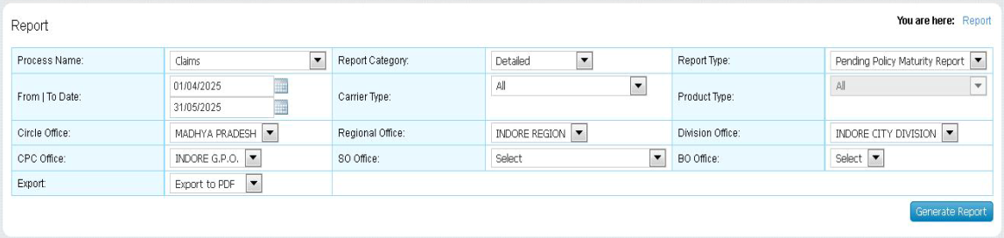

- Notification/Intimation Letter
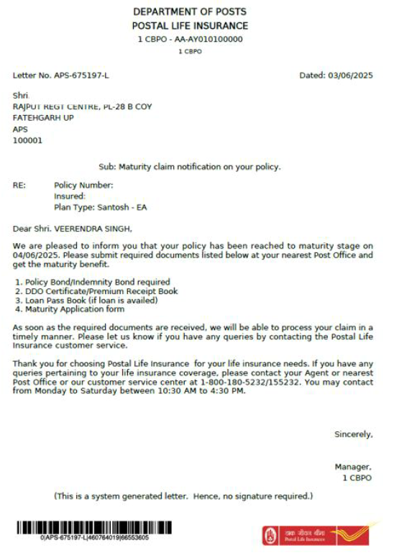
- Maturity Request Indexing:
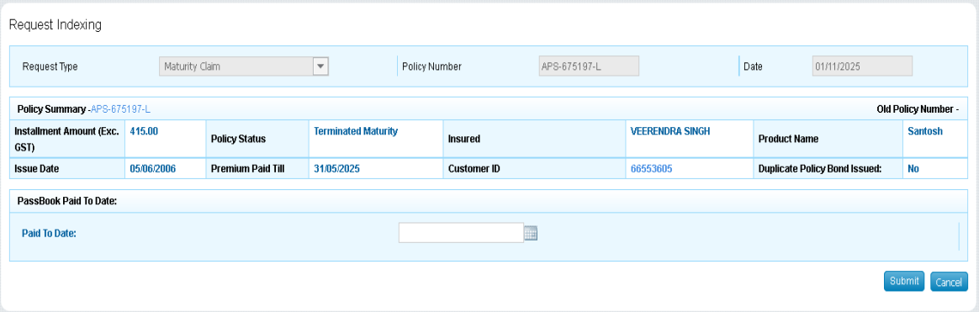

- Data Entry Screen:
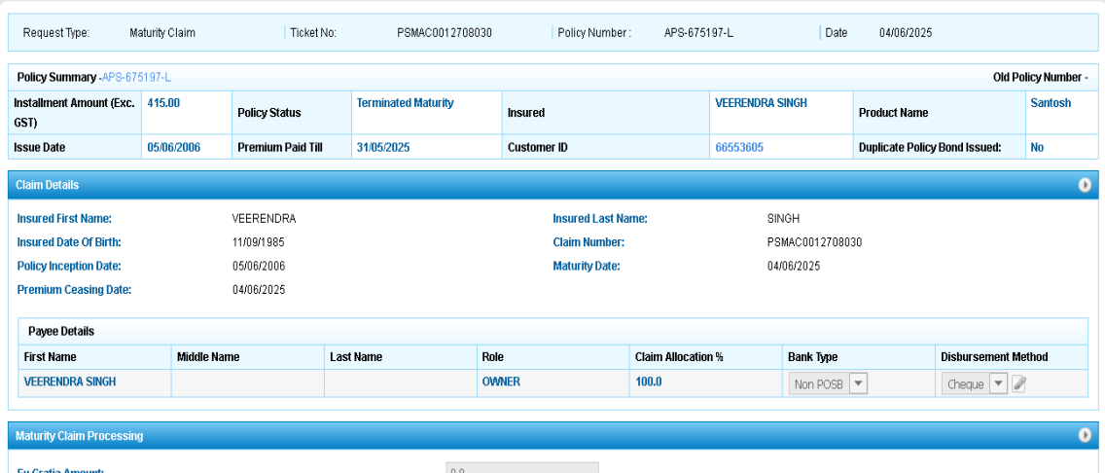
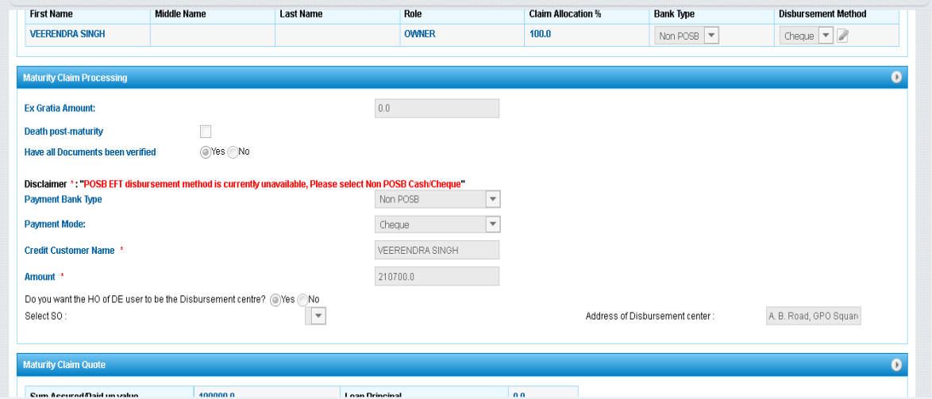
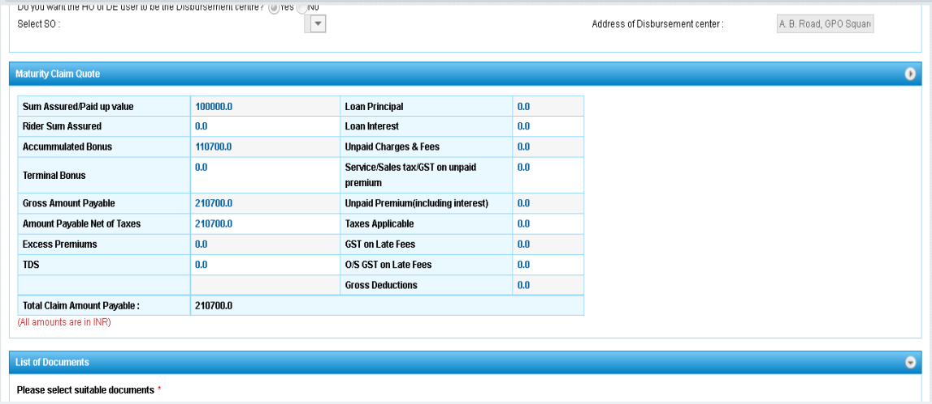
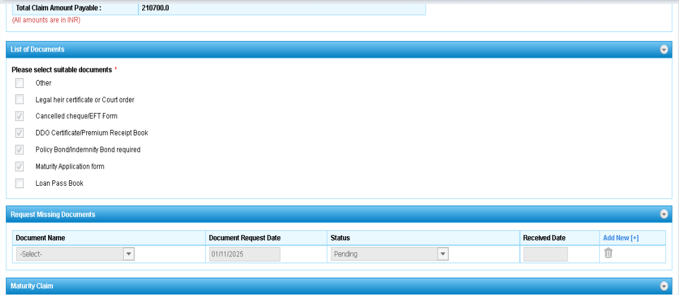

- Missing Documents Page
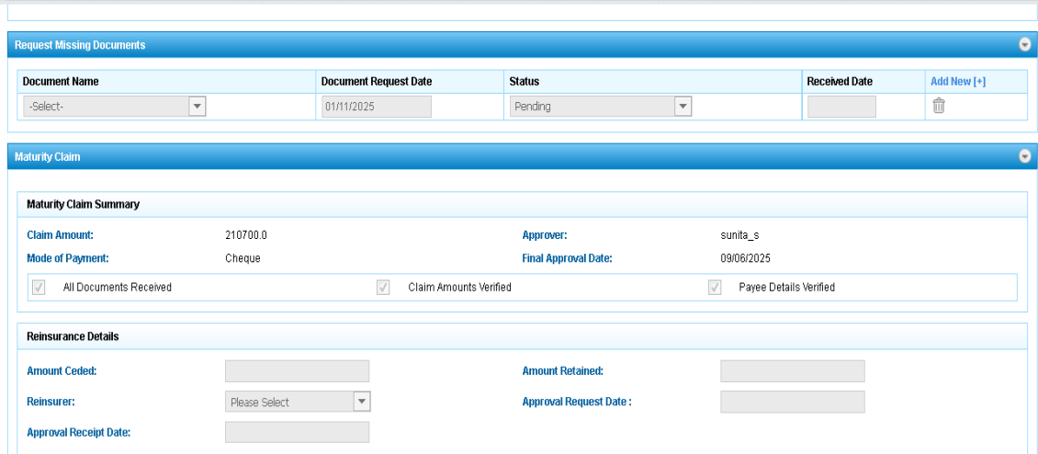

- Approval Letter
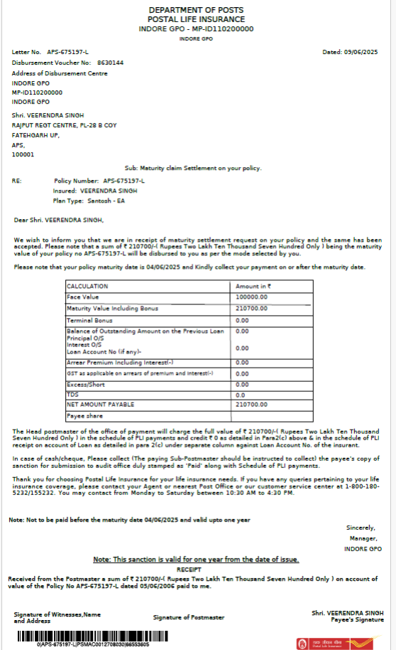
- Disbursement Update
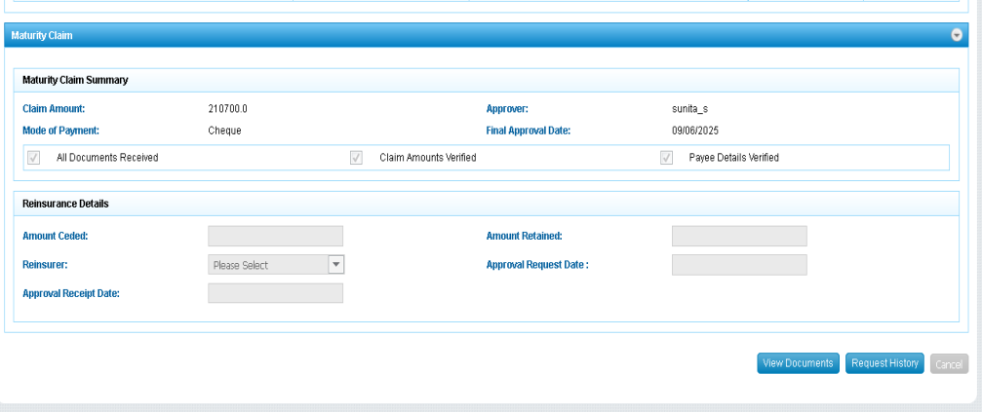

Test Cases:
POSITIVE TEST SCENARIOS (User Perspective)
P-01: Successful receipt of Maturity due intimation
- User receives Maturity due intimation via SMS / Email / WhatsApp / Portal notification.
- Message contains correct policy details and a secure claim submission link.
P-02: Secure claim link opens correctly
- User clicks the secure link received in intimation.
- User is redirected to official Customer Portal / Mobile App.
- Policy and customer details are auto-fetched and displayed correctly.
P-03: Successful online maturity claim submission
- User fills maturity claim form correctly.
- All mandatory documents are uploaded.
- Claim is submitted successfully without errors.
P-04: Auto-acknowledgement generation
- System generates a unique Claim ID upon submission.
- Acknowledgement is shown on screen and sent digitally.
P-05: DigiLocker integration works successfully
- User fetches documents from DigiLocker successfully.
- Documents are attached correctly to the claim.
P-06: Auto-reminders received for pending documents
- System sends reminders for missing documents.
- Reminder clearly mentions pending documents.
P-07: Claim status tracking works correctly
- User tracks claim through Portal/App.
- Stage-wise status updates are visible.
P-08: Sanction letter received after approval
- User receives sanction letter digitally.
- Letter contains correct claim details.
P-09: Successful payment of maturity amount
- Amount credited via NEFT/IMPS.
- Status updated as Paid in tracker.
P-10: Feedback submission after claim settlement
- User receives feedback request.
- Feedback submitted successfully.

NEGATIVE TEST SCENARIOS (User Perspective)
N-01: Secure claim link does not open
- Link is invalid or expired.
- Error message is displayed.
N-02: Missing mandatory documents
- Submission attempted without required documents.
- System blocks submission.
N-03: Invalid document upload
- Unsupported file format or size.
- Upload error shown.
N-04: DigiLocker fetch failure
- Consent denied or technical issue.
- Manual upload option available.
N-05: Incorrect bank details entered
- Wrong account number or IFSC.
- Bank verification fails.
N-06: Claim rejected by authority
- Claim rejected due to discrepancy or ineligibility.
- Rejection letter sent with reason.
N-07: Tracker not accessible / delayed update
- Portal/App unavailable.
- Status not updated immediately.
N-08: Payment failure
- Disbursement fails due to technical/banking issue.
- User informed payment failed or pending.
N-09: Feedback link not opening
- Feedback page fails to load.
- Retry/error message shown.

